

Draw It or Lose It

CS 230 Project Software Design Template
Version 1.0

Table of Contents

CS 230 Project Software Design Template 1
Table of Contents 2
Document Revision History 2
Executive Summary 3
Requirements 3
Design Constraints 3
System Architecture View 3
Domain Model 3
Evaluation 4
Recommendations 5

Document Revision History

Version | Date | Author | Comments
1.0 | 09/28/2025 | Justice Turner | <Brief description of changes in this revision>

Executive Summary and Requirements

The Gaming Room would like to make a web-based game based on the currently Android-only game ‘Draw It or Lose It’. The game needs to have the ability to have one or more teams involved, with each team having multiple players assigned to it. The game and team names must be unique, and only one instance of the game can exist within the memory at a time. The game involves the system drawing from a prompt while the other players attempt to guess what the system is drawing. Whoever guesses first wins that round of the game. The system will draw based on a database of stock images.

Design Constraints

The clients would like the game to be cross-platform, and as such it will need to fit hardware capabilities for all devices it could be used on. This means it should have lower hardware usage for use on older laptops and phones. The game will also need anti-cheat software, that are compatible with a large range of devices, and the web-application will need end-to-end encryption to prevent data leakage.

System Architecture View

Please note: There is nothing required here for these projects, but this section serves as a reminder that describing the system and subsystem architecture present in the application, including physical components or tiers, may be required for other projects. A logical topology of the communication and storage aspects is also necessary to understand the overall architecture and should be provided.

Domain Model

The entity class has two private attributes, ID and name, with functions to assign ID, get ID, get Name, and convert the information in a String. Inherited from the Entity class is the Game, Team, and Player classes. The Game Class holds association with the Team class and the GameService Class; it has one attribute which is an Array List of the team players, and it has functions to get the Game’s ID and Name, to add a team, and to convert the information to a string. The Team Class has association with the Game and Player classes, it has one attribute which is an arrayList of players. The Team list has three functions, one to get the Team ID, one to add a player to the team, and one to convert the Team information to a String. The Player class has association to the Team class, and it has two functions: get a player’s information (ID and name) and convert it to a String. The GameService class has association with the Game class. It has five private attributes, a games arrayList, a nextGameID long, a nextPlayerID long, a nextTeamID long, and a GameService service. It has one private function, GameService(). The rest of the functions are to get an instance of the GameService, to add a game to the arrayList, to get a game from the arrayList (both by ID and name), to get the next player’s ID, and to get the next Team’s ID.
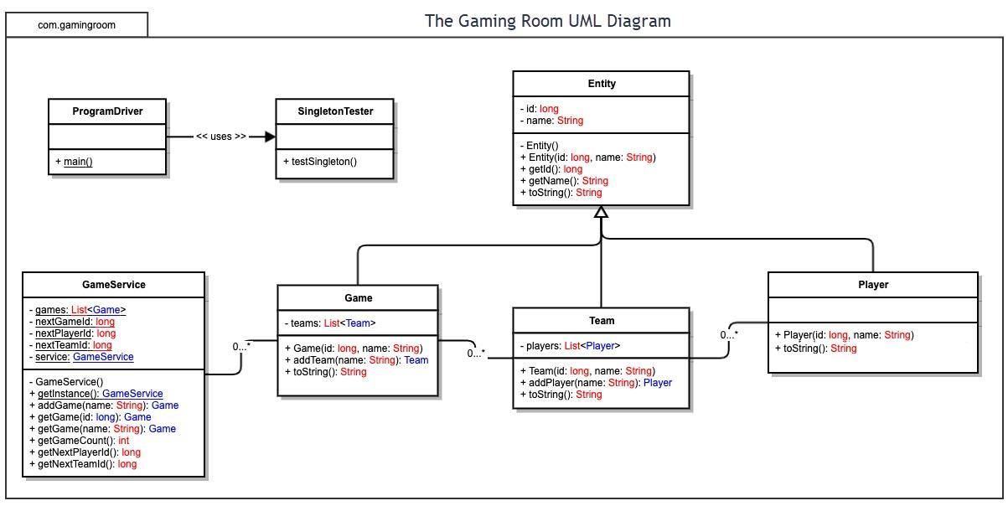

Evaluation

Development Requirements | Mac | Linux | Windows | Mobile Devices
Server Side | Mac offers unix-based web hosting services, which have strong security and user-friendly interfaces, but Mac hardware tends to be more expensive and limited, meaning that it’s less scalable and cost effective. | Linux is open source, which makes it easy to use and find resources, and makes it extremely cost-effective, and it also offers high security; but it is a steep learning curve for new users who are unused to Linux. | Windows is known for user friendliness and how wide-scale the use of their platform is, and their web hosting includes natural integration with SQL, but it requires heavy resource use, and has more security vulnerabilities. | Mobile Devices have limited battery and computational power, making them a weak option, though they are extremely widespread, with the majority of the population owning one. This also leads to a higher security risk, and more potential for data breaches.
Client Side | Mac would be an expensive option for running multiple servers, as there will need to be specific expertise and testing for the servers, and the licensing for Mac is rather expensive, it also would require more development time to allow for compatibility across macOS devices and frameworks. | If using the open-source options available through Linux the costs for running the servers would remain low, but there are commercial options that can cost significantly more than options such as Windows. The expertise required for Linux is also higher, as it is a harder system to use for beginners, and is known for being less user-friendly. | Windows requires more cost, time, and expertise to handle the diverse platform-specific features, hardware limitations, and user skill levels. Because of this more thorough testing is needed for windows based web-servers. | Mobile devices require more time and higher costs due to having to consider cross-platform (macOs, android, harmonyOS, etc), and native development and having to devote more development time due to the complexity this causes.
Development Tools | development languages: HTML, CSS, javaScript, swift  IDE: xcode, PyCharm | languages: HTML, CSS, javaScript  IDE: Visual Studio  Additional: Containerization, Phaser, MongoDB | Languages: html, css, javascript, SQL, python  IDE: Visual Studio/PyCharm  Additional: pip, MySQL, IIS, Azure | Languages: HTML, CSS, JavaScript, PHP  IDE: Visual Studio, WebStorm  Additional: Node.js, Apache Cordova, MongoDB, Google Cloud Hosting, GitHub Actions

Recommendations

- Operating Platform: Java Virtual Machine would be a good choice for operating platform, as it offers cross-platform compatibility and broad device support, including x86 and ARM. It also has a built-in memory management system, helping minimize data leaks.

- Operating Systems Architectures: The Java Virtual Machine architecture provides a runtime environment in java bytecode, enabling platform independence, which allows more versatility for cross-platform usage.

- Storage Management: PostgreSQL is the most recommended storage management system for the java virtual machine. It adheres to typical SQL standards, and is open-source, it also supports a wide variety of devices, making it useful for expansion. It should also be easy for a novice user to pick up, due to the simplicity of SQL inherent in its design.

- Memory Management: The Java Virtual Machine automatically manages memory, and abstracts the complexities of low-level memory allocation from the developer. This makes it less prone to data leakage, and easier to manage by fewer developers.

- Distributed Systems and Networks: JVM uses its networking capabilities to connect client and server components, enabling cross-platform communication through remote method invocation. The client would need multiple servers to manage the game state, user data, and matchmaking, with JVM a java application running on the client’s device could interact with the user servers, with the JVM allowing for platform-specific code to execute based on user device.

- Security: JVM has built in security, it isolates unknown code and quarantines it to prevent corruption. It also includes bytecode verification and a class loader to manage namespaces appropriately.

